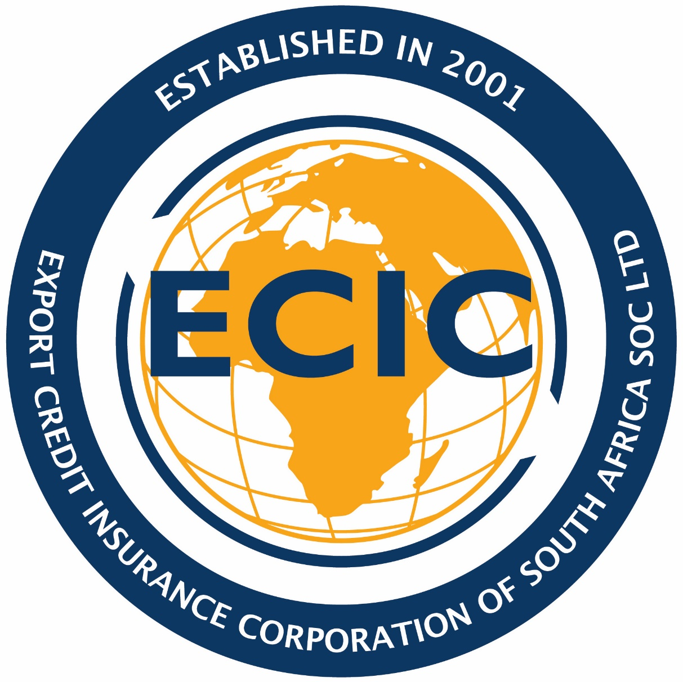

EXPORT CREDIT INSURANCE CORPORATION OF SOUTH AFRICA LIMITED

CONFIDENTIALITY/AUTHORISATION FOR LIMITED DISCLOSURE
All information contained in this Form will be treated by ECIC as confidential material. However, ECIC may be required to disclose the documentation or information contained therein, or attached thereto, to its professional advisors, law enforcement or regulatory authorities, and insurance partners as there may be from time to time, it being further understood that this information will only be disclosed by ECIC on the basis of each recipient(s) acknowledging to observe similar obligations of confidentiality in respect of that information. The Applicant understands and hereby agrees that, by submitting this Application Form, its attachments and any additional information to be submitted by the Applicant at a later stage, the Applicant has expressly authorized ECIC to disclose the documentation or information contained in the Application form in the manner aforementioned.

1. Applicant
1.1 Details of Applicant
Name of Company (Indicate party [& legal form – private, public, and other] on whose behalf the application is being made):
Contact Details (Name and address of contact person):----------------------------------------------------------------------------------------------------------------------------------------------------------------------------------------------------------------------------------------------------------------------------------------------------------------------------
VAT Number: -----------------------------------------------------------------------
Registration Number: ---------------------------------------------------------
Physical Address: -----------------------------------------------------------------------
Email: -----------------------------------------------------------------------
Telephone Numbers: -----------------------------------------------------------------------
Registration Number: -----------------------------------------------------------------------

Value and destination of major contracts / projects executed over the past three years:
Year | Product/Service | Value (US$ Million) | Destination

Were some/any of the abovementioned contracts/projects done on a project finance basis (in other words did the financier(s) provide some or all of finance against the strength of the envisaged cash flow of the project(s))?

If so, how did the project(s) perform in terms of the repayment of finance?

2. Details of Buyer/ Borrower

2.1 Full Name:

2.2 Physical Address:

2.3 Postal Address:
2.4 Activities:

2.5 Is the Buyer/Borrower state-controlled or state-owned? YES/NO
(Please supply copies of the audited financial statements of the Buyer/Borrower for the past three years, if available).

3. Details of Proposed Contract/Project
3.1 Description of goods or plant to be delivered or works to be carried out or services to be rendered (indicate whether on turnkey basis or otherwise)

3.2 Estimated Date of Contract/Project Commencement
3.3 Estimated Date of Completion
3.4 Estimated Construction or Delivery Schedule
3.5 Delivery will take place at and shall be constituted by

3.6 Estimated Contract Price/Project Cost (ZAR/US$/€)

3.7 Does the contract forms part of a larger project state? YES/NO
3.7.1 The total project value
3.7.2 South African portion of the project (ZAR/US$/€)
3.7.3 Other countries participating in the project
3.7.4 How is the total project financed? Debt/Equity
3.8.1 Provide bankable feasible study/ Project information memorandum (preliminary)

3.8.2 Any other relevant information

4. Details of payment Terms Required by the Buyer/ Borrower
4.1 Principles Terms
4.1.1 Percentage on Contract Signature
4.1.2 Percentage on Delivery
4.1.3 Percentage on Credit
4.2 Repayment period/Tenor
4.3 Currency Payment (ZAR/US$/€)

5. Details of Payment Guarantee or Sponsor support, if any:
5.1 Full names of Guarantor/Sponsor
5.2 Full Address of Guarantor/Sponsor

5.3 Please supply copies of the audited financial statements of the Guarantor/Sponsor for the past three years, if available.

6. Details of Project Agreements
6.1 Status and list of supply agreements for the project
6.2 Status and list of off-take agreements for the project

6.3 Status and list of all other projects agreements/ licenses required/ obtained

6.4 Project operator and maintenance provider for the project

7. Analysis of the South African Contract Price or relevant content backing the ECIC supported loan by origin of supplies and/or services:
SUMMARY | VALUE (US$ Millions) | % of Contract Price of % of the ECIC supported loan (indicate applicable basis for the %)
7.1 South African Content
7.2 Host Country or another African Country Content
7.3 Foreign Country Content (Outside of Africa)
GRAND TOTAL:

SOUTH AFRICAN CONTENT | VALUE (US$ Millions) | % of Contract Price of % of the ECIC supported loan (indicate applicable basis for the %)
Goods and services
Insurance and freight charges, if any
Services
Charges³, credit, Insurance premiums, commission etc :
Overheads and profit
SUB-TOTAL :

HOST COUNTRY/ ANOTHER AFRICAN COUNTRY CONTENT | VALUE (US$ Millions) | % of Contract Price of % of the ECIC supported loan (indicate applicable basis)
Main goods/ Services originating from country of destination
Goods and materials
Transport costs and duties
Labour
Other expenses
SUB-TOTAL:

FOREIGN COUNTRY CONTENT | COUNTRY | VALUE (US$ Millions) | % of Contract Price of % of the ECIC supported loan (indicate applicable basis)
Main goods/ Services originating from country of destination
Goods and materials
Transport costs and duties
Labour
Other expenses
SUB-TOTAL:

- Reasons (if any) why the goods / services mentioned in 7.2 and 7.3 will not be supplied from South Africa (refer to page 5).

9. Anti-Bribery, Sanctionable Practices and Anti-terror Financing Policy

9.1 Exporter’s Undertaking/Declaration

Exporter:
(Full legal names and registration number)

Undertaking against bribery, sanctionable practices and terror financing
We confirm that neither we nor anyone acting on our behalf, such as employees or agents, have been engaged or will be engaged in acts of bribery of foreign public officials or have committed or will commit bribery in connection with the export contract forming part of this application or are involved in sanctionable practices and terror financing activities (as defined in ECIC Sanctionable Practices and Anti-Terror Financing Policy).

Declaration of bribery charges or convictions
Is the exporter or anyone acting on their behalf in connection with the transaction charged or convicted in a national court or equivalent national administrative measures for the violation of laws against bribery or bribery of foreign public officials of any country (including South Africa) within a five-year period preceding the application?

YES NO

Internal Control System
We have noted ECIC’s initiative to encourage us to develop, apply and document internal management control systems to detect, prevent and combat bribery in international business transactions within our organizations.

Consequences of Bribery
We take notice that in terms of the Prevention and Combating of Corrupt Activities Act 2004 (Act No. 12 of 2004) bribery of foreign public officials in international business transactions is crime in South Africa and contravention thereto is punishable with a fine and imprisonment including life sentence.

We also take notice that ECIC has the right to refuse to provide export credit support in connection with this application if:

- the exporter(s), and where applicable, the applicant, is listed on the publicly available debarment list of one of the following international financial institutions: World Bank Group, the African Development Bank, the Asian Development Bank, the European
Bank for Reconstruction and Development, and the Inter-American Development Bank; or
- the exporter(s), and where applicable, the applicant, is under charge or has been convicted in a national court or equivalent national administrative measures for the violation of laws against bribery of foreign public officials of any country within a five year period preceding the application; or
- credible evidence of bribery is found in connection with the award or execution of the export contract(s) or
- the exporter(s) or where applicable, the applicant, is in breach of the ECIC Sanctionable Practices and Anti-Terror Financing Policy.

For and on behalf of the Exporter Full names:
Position:
Date:

10.1 Agent’s Commission
10.1.1 Please state the details of the Agent or any person acting on the exporter or
applicant’s behalf in connection with the export contract or the project:
10.1.1.1 Full Names:
10.1.1.2 Registration Number / Identification Number:
10.1.1.3 Full Physical Address:
10.1.1.4 Details of Business Activities:

10.1.2 Please state the amount you will pay or anticipate paying as agent's commission in respect of the procurement/handling of the export contract(s) and purpose of the commission or fee:

10.1.3 Is this amount included in items 7.1, 7.2 or 7.3 above? (Specify item)

10.1.4 When do you expect to pay this commission?

11. US Dollar/S.A. Rand Exchange Risk Cover can, under certain circumstances, be made available by the ECIC
11.1 Is such cover required
If the answer to 11.1 is yes, please indicate whether cover is required for 4.1.1 plus 4.1.2 plus
4.1.3. :

12 . Environmental & Community Impact
12.1 Has an environmental impact study been done for the project, and, if so, by whom, and what were the results?

13. Employment Effect
13.1 Please provide information about the estimated job creation effect of the project both in South Africa and the buyer country.⁶

Signed at this day of 20___

____________________ _____________________
Authorised Signature Name (In Block Letters)

________________________________
⁶ Thumb-suck figures are not acceptable - Scientific basis for figures needs to be demonstrated.
ANNEXURE A

1. Assessment Fees for New Applications
The fee charged for every new application will be a fixed percentage of the proposed ECIC backed Loan Amount. The ECIC backed Loan amount is to be determined by aggregating the values of the relevant South African exports’ contracts used for purposes of tracking and reporting South African content. The percentage to be charged in this regard will be 0,025% of the proposed ECIC backed Loan Amount as indicated in Annexure “C”. The application fee shall be paid after approval of the transaction by the relevant delegated authority.

The maximum assessment fee payable is capped at US$15,000-00. However, ECIC management reserves the right to alter this in the case of large projects.

In the event that the South African Loan Amount or the reference South African Contract Price increases after having paid the assessment fee, the assessment fee may be adjusted accordingly based on the increased amount of the South African Loan Amount or the reference South African Contract Price, subject to the cap mentioned above.

In the event that the insurance application for the project is approved by the ECIC and the relevant policies of insurance are executed the total assessment fee paid will not be reimbursed by ECIC.

The Assessment fee will be invoiced after approval of the transaction by the relevant delegated authority.

2. Fee for an Extension of an Offer of Cover
A flat fee of US$1,000-00 will be charged in respect of each request for an extension of the validity period of an offer of cover once it has lapsed. This fee will not be reimbursed by the ECIC.

In the case of the non-approval of an extension for an Offer of Cover presented to the Project Executive Committee the first option extension fee of US$ 1,000-00 plus tax paid by the client, will be refunded. In all other cases option fees are not refundable.

No interest shall be paid on any fees refunded to the client.

3. Invoicing of the Fees
It should be noted that the fees as well as the VAT charges thereon would be invoiced and payable in US Dollars. However, in the event that a client is unable to pay the fee in US Dollars, the ECIC should be notified. At the ECIC’s discretion, the client may be required to pay the Rand equivalent amount at the Rand/US Dollar spot rate applicable or quoted on the date of issuing the invoice by the ECIC.

4. Validity Period for Offers of Cover
The validity period for an offer of cover, including any subsequent extension, will be six (6) months and that period shall commence from the date of issue of the offer of cover. Any extension for the validity period of an offer of cover that has elapsed will be subject to the payment of the US$1000, as explained in paragraph 2. above.

ANNEXURE B SOUTH AFRICAN CONTENT
The following items shall be deemed to constitute South African Content:
- the cost of materials and manufactured goods purchased from South African suppliers minus the value of any materials, goods or major components of manufactured goods which have been imported from sources outside South Africa;
- wages, salaries and other remuneration paid by the exporter(s) in South Africa to his employees and such portions of wages, salaries and other remuneration payable to the exporter’s employees who are performing work outside South Africa, and which is paid by the exporter(s) in South Africa;
- (a) freight charges paid in respect of a policy issued in South Africa;
  - insurance premiums paid in respect of a policy issued in South Africa;
  - finance charges, excluding any interest for post-delivery finance, paid to any financial institution normally operating in South Africa;
  - fees and charges paid for any other services performed in South Africa on the exporter’s behalf by South African resident organization;
- fees and profits accruing to the exporter(s) to the extent that the ECA/Chartered Accountants have confirmed that they qualify as South African content.
Your attention is also drawn to the fact that the payment of freight charges to a company normally doing business in South Africa will not necessarily qualify as South African content since the whole or part of such payment may relate to freight costs incurred in respect of a shipping line or vessel which in the ECIC’s opinion does not qualify as South African.

ANNEXURE C ASSESSMENT FEES

ECIC backed loan amount  $ Million | ECIC backed loan amount  0,025%
1 | 1 000
2 | 1 000
3 | 1 000
4 | 1 000
5 | 1 250
10 | 2 500
15 | 3 750
20 | 5 000
25 | 6 250
30 | 7 500
35 | 8 750
40 | 10 000
45 | 11 250
50 | 12 500
55 | 13 750
60 + | 15 000

ANNEXURE D
IMPORTANT – PLEASE READ CAREFULLY | 3. OTHER MATTERS OF IMPORTANCE
As a short-term insurance policyholder or prospective policyholder, you have the right to the following information:  1 GENERAL INFORMATION  Registered Name: Export Credit Insurance  Corporation of South Africa SOC Limited  Abbreviated Name: ECIC  Registration Number: 2001/013128/06  VAT Number: 4170197125  FSB License Number: 30656  FSB License Category: Short Term Insurance,  Commercial Lines, Financial Advisory Services and  Financial Intermediary Services  E-mail: (www.info@ecic.co.za)  Website: www.ecic.co.za  Telephone: +27124713800  Fax: +2712 471 3850/51  Office: 349 Witch Hazel Ave, Highveld Ext 79,  Centurion  P O Box 7075, Centurion, 0046 Any changes to the above information will be communicated to you in writing  2. COMPLIANCE DEPARTMENT  Senior Compliance Officer: Ms Simangele Sealetsa  Telephone: + 27 12 471 3871  Mobile : + 27 84 657 5601  Email: S Sealetsa @ecic.co.za  Delivered to our offices addressed to: “The  Compliance Officer” | - ECIC issues policies on its behalf with the government as the ultimate insurer;  - ECIC must give written reasons for repudiating your claim;  - ECIC is obliged to notify you directly of the cancellation of your insurance contract; and  - All the ECIC representatives have a letter of appointment verifying the ECIC accepts responsibility for activities performed within the scope of, or in the course of their mandated duties.  - THE FAIS OMBUDSMAN  If any complaint made to the intermediary or insurer is not resolved to your satisfaction, you may submit your complaint to the FAIS Ombudsman who can be reached at: Address: PO BOX 74571  Lynnridge  0040  Email: info@faisombud.co.za  Telephone: +27 12 470 9080/0860 324 766  Fax: +27 12 348 3447  - THE SHORT-TERM INSURANCE OMBUDSMAN  The short-term Insurance Ombudsman is available to advise you in the event of claim problems which are not satisfactorily resolved by the insurer. The Ombudsman can be reached at:  Address: P O Box 32334  Braamfontein  2017  Website: www.insuranceombudsman.co.za  Telephone: + 27 11 726 8900  Fax: + 27 11 726 5501

For definition of South African Content refer to Annexure “B” ³ Excluding interest for the export credit loans.
Excluding South Africa, Host Country and any other African Country
Section 26 Chapter 5: Penalties and Related Matters in the Prevention and Combating of Corrupt Activities Act 2004 (Act No. 12 of 2004)

